Rittal at the 2024 Datacloud Global Congress
Making the IT infrastructure fit for AI
Herborn/Cannes, 2024-05-29.
The 2024 Datacloud Global Congress brings together leaders from the worlds of finance and technology, representatives of corporations and governments, as well as energy experts and surface and subsea connectivity professionals. Cooperation between them is now very much in demand, then the growth of AI applications represents both an economic opportunity and a technological challenge for the entire industry. How can the huge increase in IT infrastructure be managed so that AI can provide the sought-after benefits? Which partners can help with new technologies and accelerate projects? To this end, Rittal is entering into a dialogue with partners and visitors. And the highlights on show include a new solution to provide direct liquid cooling of over 1 MW and a new rack to accelerate the expansion of colocation.
A new technological landscape is required above all for cooling, because the power density that AI applications need and the already widespread high-performance computing are pushing air cooling to its very limits. In close cooperation with multiple hyperscalers and server OEMs, Rittal has developed a modular cooling solution delivering a cooling capacity of over 1 MW with single-phase direct liquid cooling to make the necessary power densities achievable.
High performance made easy
The secret to its success is the way several coolant delivery units are distributed across interchangeable modules inside the rack. The whole solution is designed for easy serviceability. How does it work? The Open Rack V3, which Rittal helped develop in the Open Compute Project (OCP), offers a number of advantages: Rittal uses the interfaces already defined in the OCP to set up an in-row CDU (Coolant Distribution Unit) based on the ORV3. Depending on performance requirement, functional units such as the central controller unit and several coolant conveying units (CCUs) are completely modular and integrated into the rack in slide-in units. This concept offers a major benefit in terms of service: Components such as controllers, sensors or the pump units of the in-row solution can be maintained during operation and easily replaced via “hot swap”. Power is supplied via the standardised PSUs (power shelf units, with their power supply and power supply units) and the DC busbar in the rack.

The cooling solution is a welcome addition to the Rittal system range of building blocks. It offers coordinated modules for every element of the data centre OT, including rack, cooling, power, monitoring and security. The technology is also ideal for reducing the CO₂ footprint by heat recovery. Rittal is using its experience to support data centre planning so that the heat is transported efficiently from the rack's manifold for further uses, such as district heating networks.

Everything in the rack
“Increasingly, power, cooling and monitoring are being directly integrated into the standardised rack as fundamental pillars of the IT infrastructure. The main drivers of this trend are multiple hyperscalers and server OEMs. We are their main rack supplier,” says Philipp Guth, Rittal Internationals CTO: “We are convinced that this concept will soon become the standard for our global IT customers because ever higher performance and rapid scaling will be needed. Besides hyperscalers, it will also become interesting for increasing numbers of colocators and enterprise customers.”

Speed for colocation
The colocation market is booming, and so is the demand for data centres. IT infrastructures have to deliver a lot: a high level of energy efficiency, assured quality and reliability, global standardisation, as well as the proof and receipt of certification. At the same time, the components have to be coordinated with each other and be quickly scalable. Rittal is helping colocation providers meet these requirements and help them respond quickly to rising demand with its new TX Colo Rack. “Our new rack allows providers to act swiftly and at the highest level. They can equip their white spaces with immediately available, standardised solutions of the highest quality,” asserts Anna Klaft, Vice President of Rittal’s IT Business Unit.: Full integration of new cooling solutions and other elements into the Rittal system platform is a key lever for rolling out the infrastructure needed for AI applications on a large scale – from large hyperscale data centres to small enterprise data centres.”

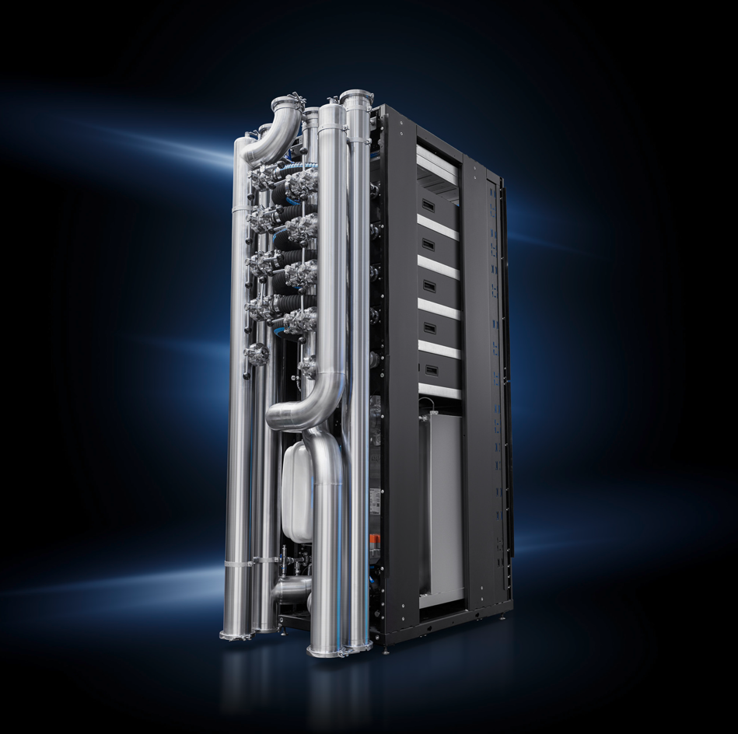 |  | 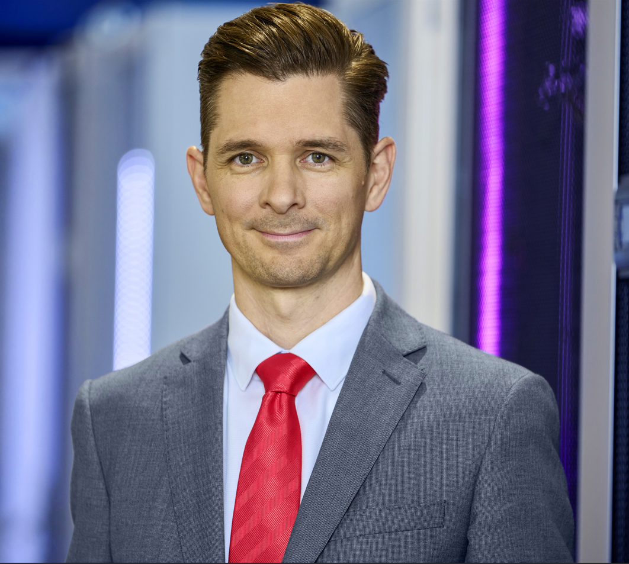
Caption, image I  Thanks to direct liquid cooling, the new modular bayed solution delivers a cooling output of over 1 megawatt, ideal for the high power densities of AI applications.  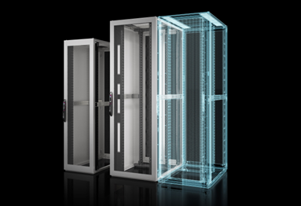  Caption, image 3  With Rittal’s new TX Colo Rack, colocation providers can equip their white spaces with readily available, standardised solutions that have been specially designed for this market. |  | Caption, image 2  Philipp Guth, CTO Rittal International: “A high level of standardisation and scalability through modular design and global availability is required to enable rapid infrastructure expansion technically, economically and organisationally.”    Caption, image 4  “With our new rack, providers can act in the shortest possible time and at the highest possible level” says Anna Klaft, Rittal’s Vice President Business Unit IT.
May be reproduced free of charge. Please name Rittal GmbH & Co. KG as the source.

Rittal

Rittal is a leading global supplier of enclosure systems, automation and infrastructure with its industrial, IT, energy and power, cooling and service units. Rittal products and solutions are used in over 90% of global industries – standardised, customised, and always of the very best quality. Our approach and methodology: Rittal, Rittal Software Systems (Eplan, Cideon and German Edge Cloud) and Rittal Automation Systems (RAS, Ehrt, Alfra) combine their hardware and software expertise to streamline, optimise and digitalise processes across the entire value chain for our customers including their IT infrastructure – from control and switchgear construction, machine building to factory operators or the energy sector.
Our delivery promise: Rittal standard products are delivered in Germany within 24 hours, and within 48 hours throughout Europe.
Customer focus
Improving efficiency and increasing productivity through automation and digitalisation is one of the biggest challenges for our customers. This requires in-depth knowledge and expertise, the combination of hardware and software, and cross-sector networking. We are convinced that creating and connecting data rooms is crucial to the success of industrial transformation. And that is exactly our speciality and field of competence. Eplan and Rittal are driving the development of the digital automation twin, making data accessible and useable in operations as well. Cideon is improving data consistency in the digital product twin context with its CAD/CAM, PDM/PLM and product configuration expertise. German Edge Cloud’s ONCITE Digital Production System (DPS) makes production process data transparent, enabling it to be optimised – right through to energy management using digital production twins.
Sustainability
Environmental and climate protection, social commitment and ethical corporate management are a given for Rittal. We take our responsibility for a sustainable future seriously. Our approach to resource management and conservation involves continuous improvement of our own production processes and ensuring that our products have the lowest possible Product Carbon Footprint. Our solutions support our customers in achieving their own climate targets.
Family business and global player
Founded in 1961, Rittal is the largest company in the owner-operated Friedhelm Loh Group. The group operates worldwide, with more than 12 production sites and over 95 international subsidiaries. It has more than 12,100 employees and posted revenues of 3 billion euros in fiscal 2023. In 2023, the Friedhelm Loh Group was presented with the “Best Place to Learn” and “Employer of the Future” awards. In 2024, Rittal was awarded the Top 100 Seal as one of Germany’s most innovative medium-sized companies for the third time in a row.
For more information, visit www.rittal.com and www.friedhelm-loh-group.com

Corporate Communications
Dr Carola Hilbrand Rittal GmbH & Co. KG
Corporate & Brand Communications Auf dem Stützelberg
Tel.: 02772/505-2527 35745 Herborn, Germany
hilbrand.c@rittal.de www.rittal.de


Follow us on:

